|  |  |  |
| --- | --- | --- |
| **Lyng Primary School P.E Knowledge Organiser** | | |
| **Topic: Basketball** | Year 4 | Autumn 1 |





**"You have to expect things of yourself before you can do them." ― Michael Jordan**

Enquiry Questions

* How can we improve our skills and accuracy?
* Why is decision making important in basketball?
* How can we understand which tactics to use in certain times of the game?
* How can we improve our shooting technique and accuracy?
* In what areas is it best to apply pressure, block or intercept in defensive scenarios?
* What are the key rules used in a game of basketball?

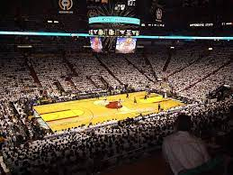 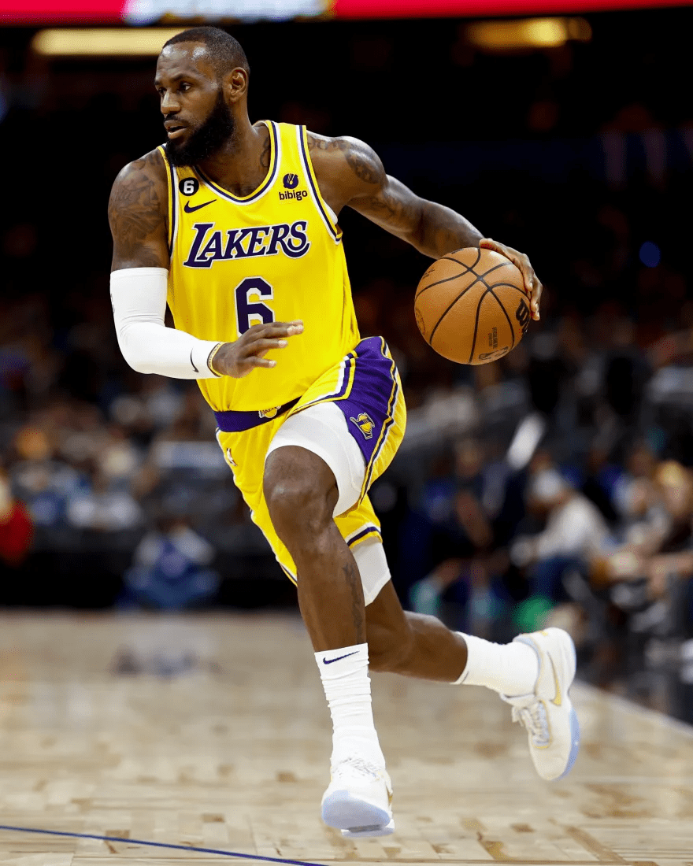

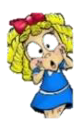

|  |  |
| --- | --- |
| **Key words** | |
| **Spelling** | **Definition** |
| Receive | Seize the ball with your hands. |
| Passes | Work through variety passes transferring the ball from one person to another |
| Dribbling | To move whilst in possession of the ball by bouncing it. |
| Shooting | Aiming for the basket to score for the team. |
| Double dribble | Foul play when dribbling with the ball if you stop and hold the ball & then dribble further this is deemed a double dribble. |
| Possession | Retain the ball for the team, so your team is in control and have the ball. |
| Communication | To interact using your voice with the team. |
| Tactics | [Methods](https://www.collinsdictionary.com/dictionary/english/method) that you [choose](https://www.collinsdictionary.com/dictionary/english/choose) in order to be successful, i.e. number of passes made, movement, defensive/offensive shape. |
| Travelling | This is foul play, moving with the ball without bouncing the ball. |

|  |  |  |
| --- | --- | --- |
| **Lyng Primary School P.E Knowledge Organiser** | | |
| **Topic: Basketball** | Year 4 | Autumn 1 |



Learning outcomes:

* To perform & links tricks together with control
* To be able to travel at speed maintaining control of the ball
* To perform a variety of passes with the correct technique & accuracy
* To perform the correct shooting technique
* To learn how to apply defensive skills such as blocking, intercept or pressure
* Understand rules and apply all areas of the game into a game situation.